AIPP ASSIGNMENT 09
NAME: CH HARSHITHA HALL TICKET NO: 2503B05135(MTECH)
Task Description#1 Basic Docstring Generation
- Write python function to return sum of even and odd numbers in the given list.
- Incorporate manual docstring in code with Google Style
- Use an AI-assisted tool (e.g., Copilot, Cursor AI) to generate a docstring describing the function
- Compare the AI-generated docstring with your manually written one

Expected Outcome#1: Students understand how AI can produce function-level documentation.
Prompt-1: Write python function to return sum of even and odd numbers in the given list.
Prompt-2: Incorporate manual docstring in code with Google Style

CODE:
# Python Function with Manual Docstring

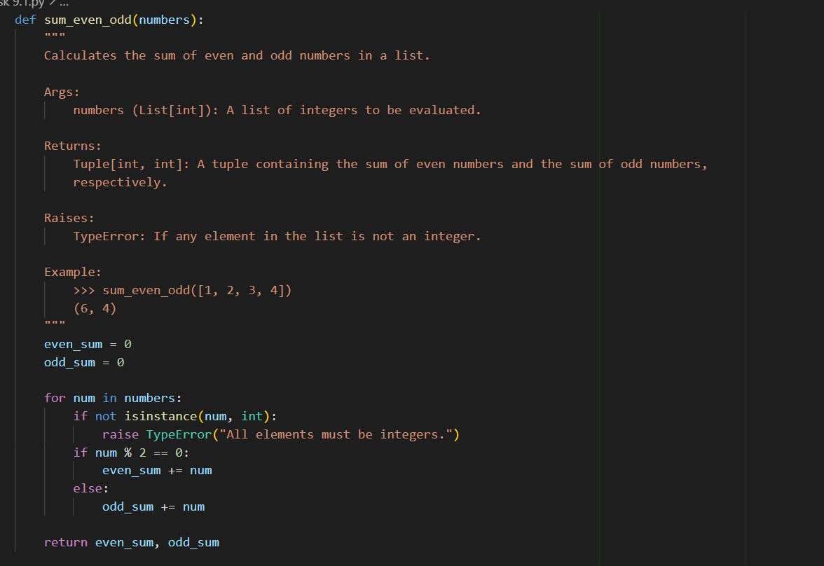

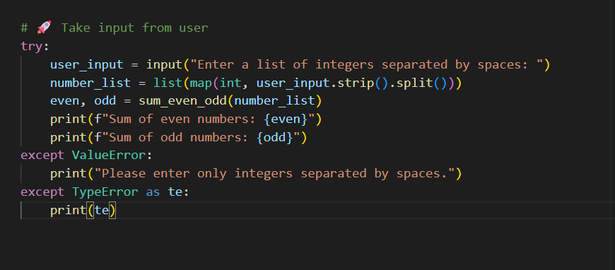
OUTPUT:
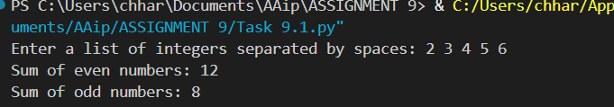

# AI-Generated Docstring (Google Style)

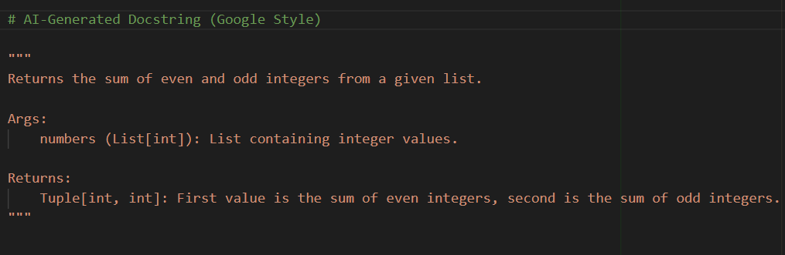
Comparison: Manual vs AI-Generated Docstrin
Feature | Manual Docstring | AI-Generated Docstring
Clarity | Very clear and descriptive | Clear but more concise
Structure | Includes Args, Returns, Raises, Example | Includes only Args and Returns
Error Handling | Mentions TypeError explicitly | No mention of exceptions
Example Usage | Provides a usage example | No example provided
Tone | Slightly more formal and instructional | More minimalistic and utilitarian

Task Description#2 Automatic Inline Comments
- Write python program for sru_student class with attributes like name, roll no., hostel_status and fee_update method and display_details method.
- Write comments manually for each line/code block
- Ask an AI tool to add inline comments explaining each line/step.
- Compare the AI-generated comments with your manually written one.

Expected Output#2: Students critically analyze AI-generated code comments.

CODE:
#Manually Commented Python Program with User Input

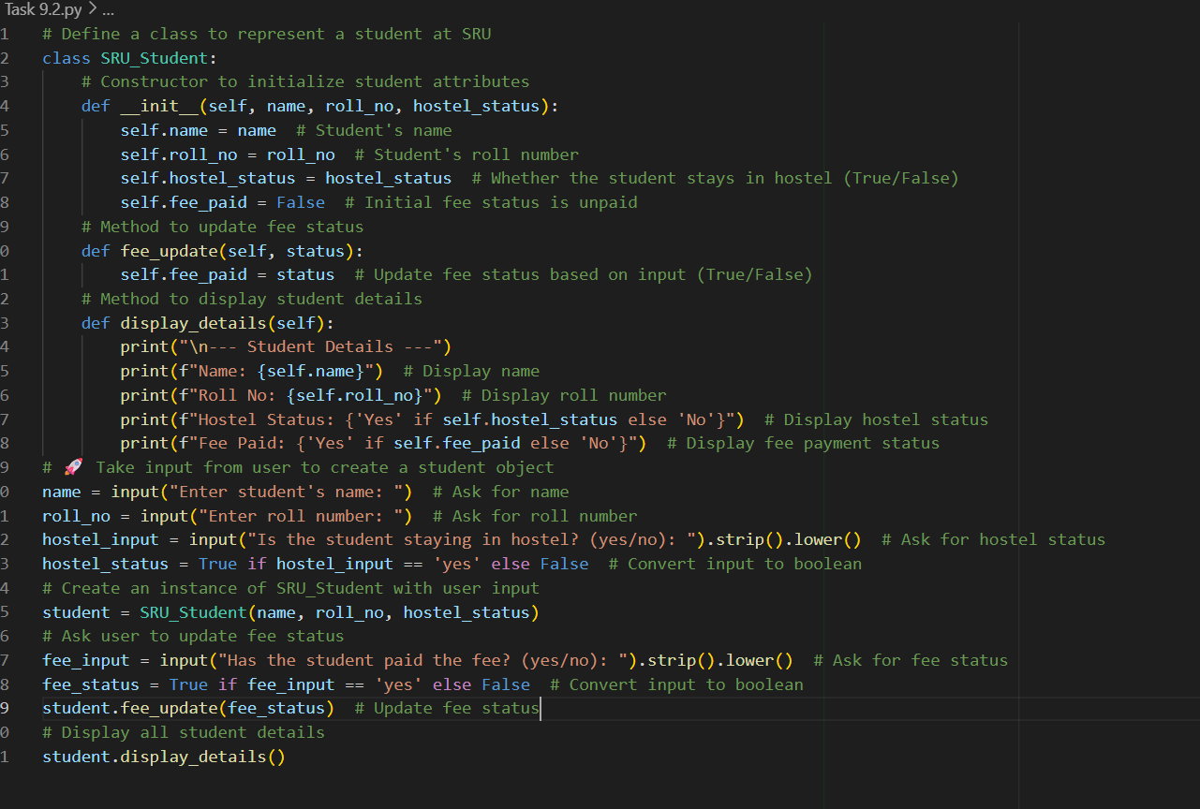
OUTPUT: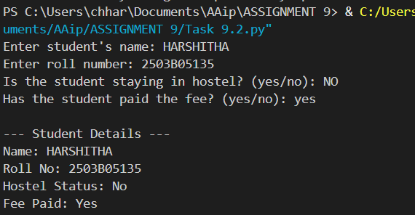

AI Generated Comments
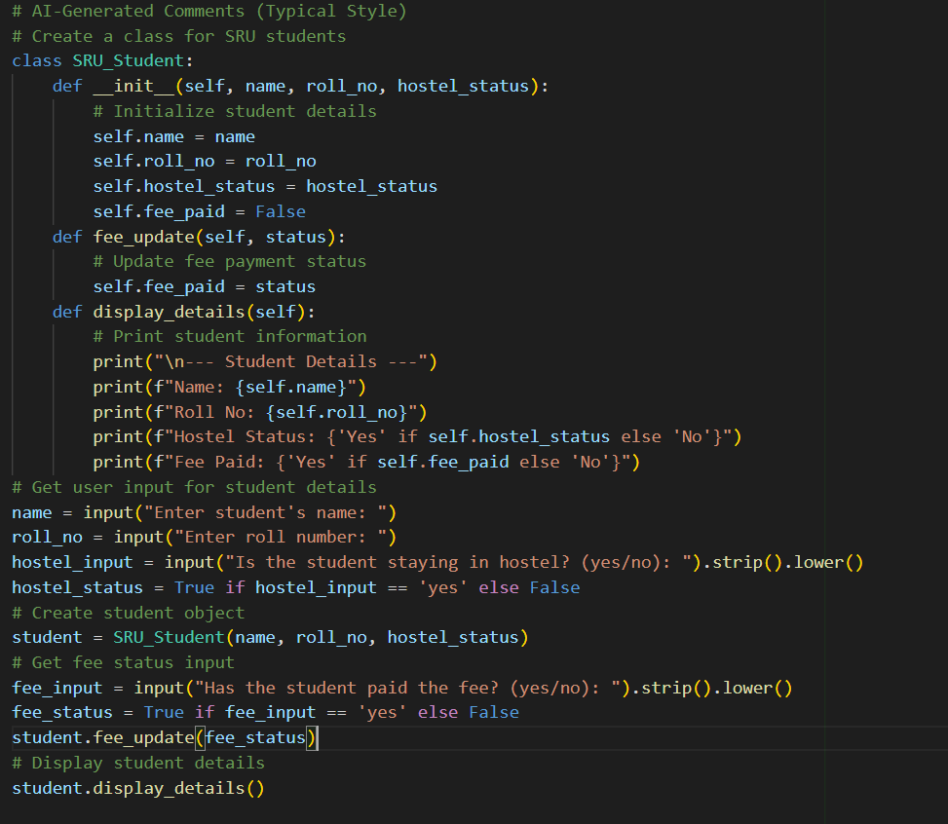
OUTPUT:
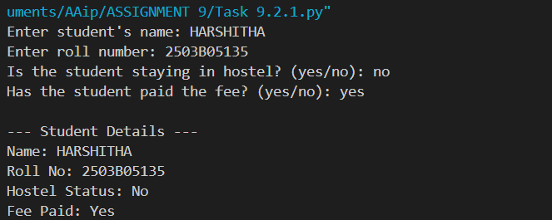

“The AI comments are technically correct but lack depth. For example, # Initialize student details doesn’t explain what each attribute represents or why fee_paid defaults to False.
Also, the comment # Create student object is vague—it could be improved by saying # Create an SRU_Student instance using user-provided data.
The AI doesn’t use inline comments, which makes it harder to follow for be
Task Description#3
- Write a Python script with 3–4 functions (e.g., calculator: add, subtract, multiply, divide).
- Incorporate manual docstring in code with NumPy Style
- Use AI assistance to generate a module-level docstring + individual function docstrings.
- Compare the AI-generated docstring with your manually written one.

Expected Output#3: Students learn structured documentation for multi-function scripts

Push documentation whole workspace as .md file in GitHub Repository

Note: Report should be submitted a word document for all tasks in a single document with prompts, comments & code explanation, and output and if required, screenshots

CODE:
#AI-Generated Docstring
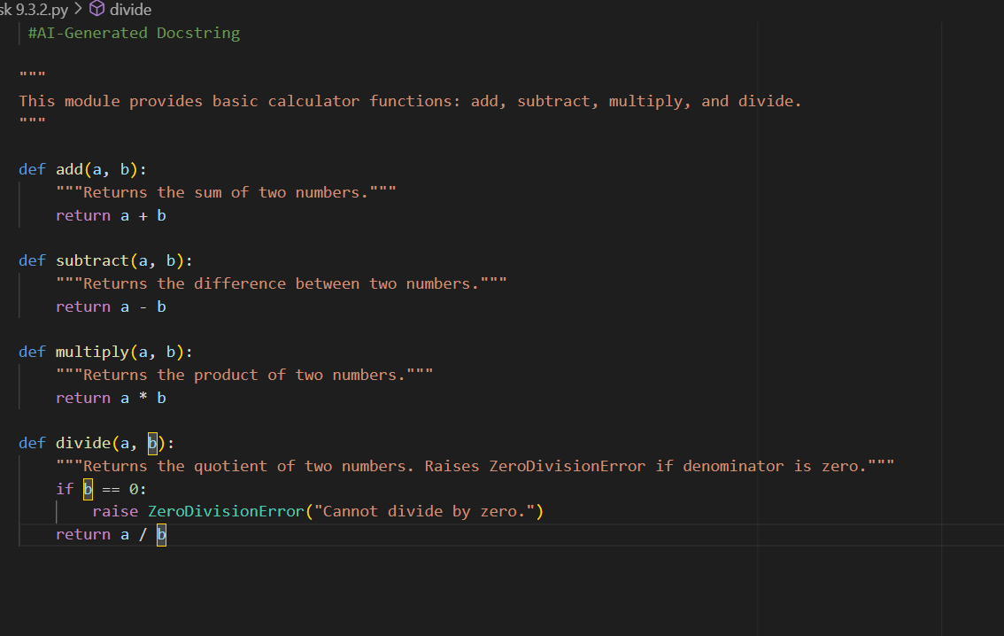

#Python Script with Manual NumPy-Style Docstrings
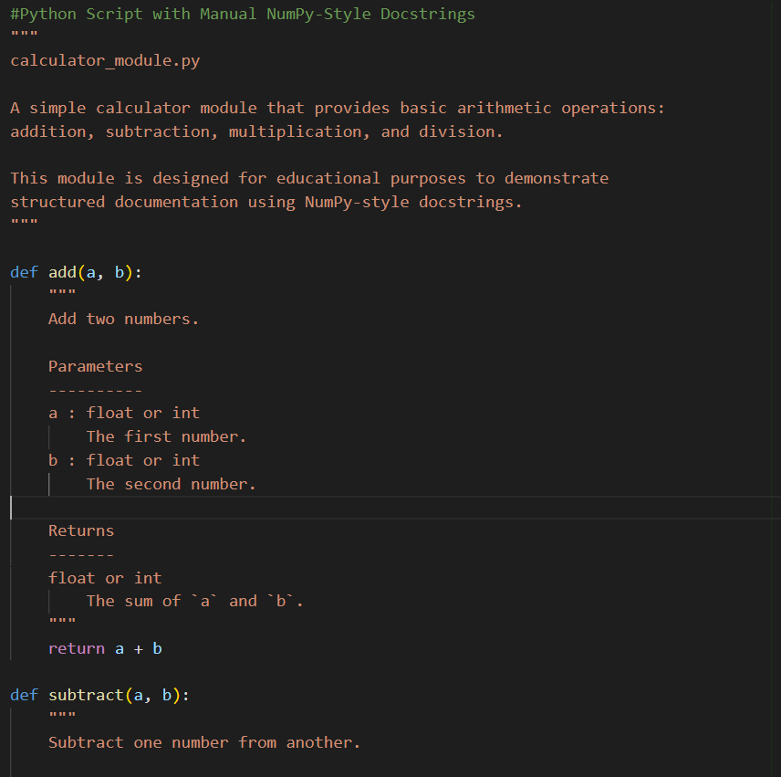
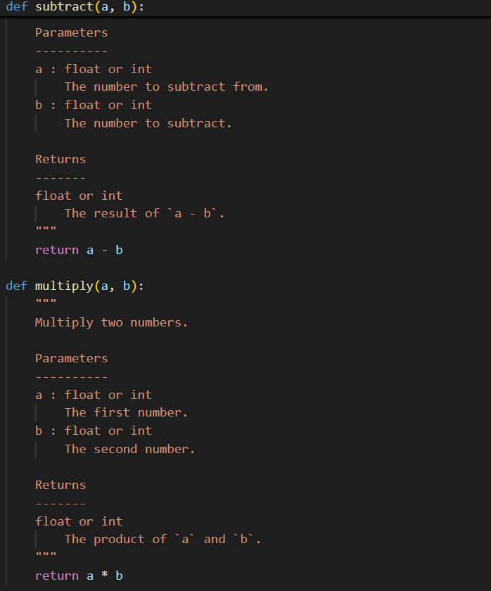

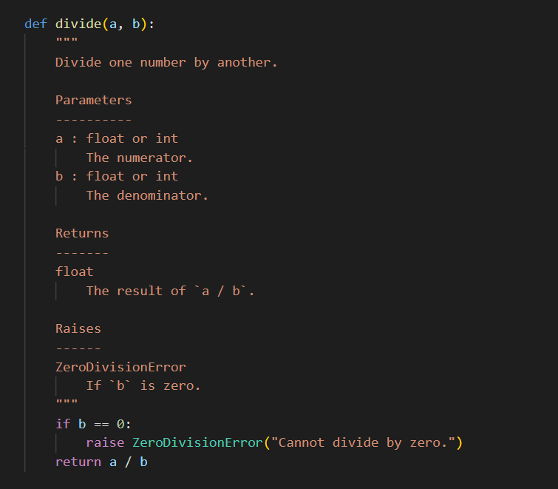
Comparison: Manual vs AI-Generated Docstrings
Feature | Manual Docstrings (NumPy Style) | AI-Generated Docstrings
Structure | Follows NumPy format with Parameters, Returns, etc. | Simple one-liners without formal structure
Detail Level | Specifies types, behavior, and exceptions | Minimal detail, no parameter typing
Educational Value | High—teaches documentation standards | Moderate—good for quick reference
Error Handling | Explicitly documents exceptions | Mentions error but lacks formal Raises section
Audience Suitability | Ideal for learners and collaborators | Suitable for quick solo use

